

SPRINT 2

Project 1 – UI & Reports



Robot Team 2

Finalized April 19, 2022

**User Interface Design**

**Main Menu Screen(Fullscreen Version)**

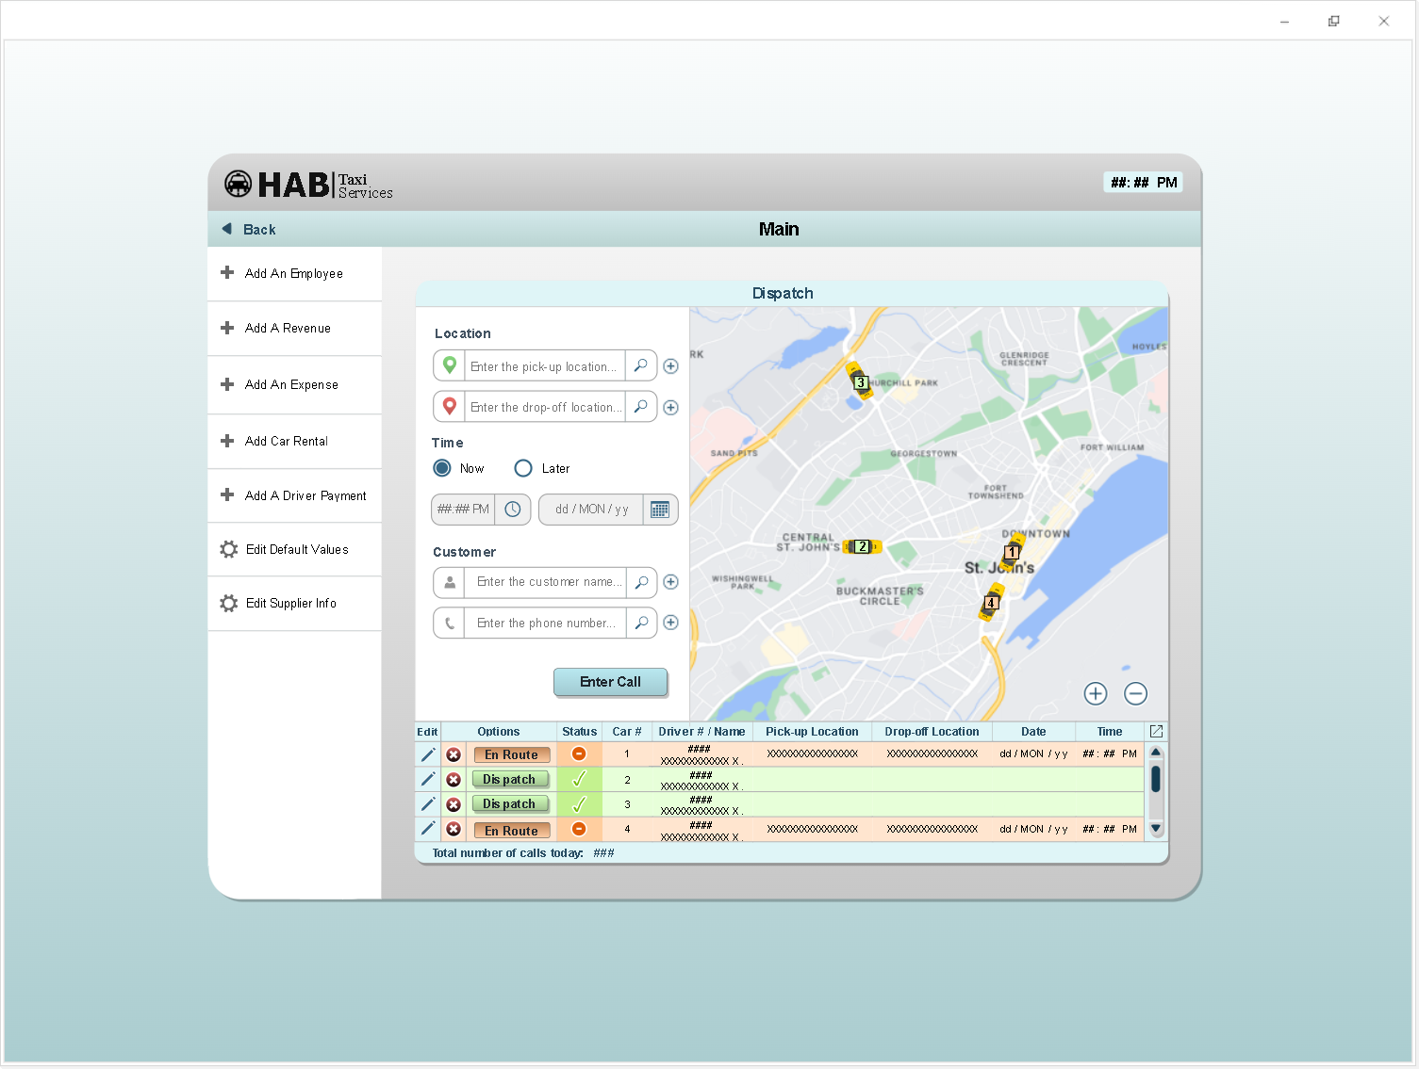

**Beneficial Features Included**

1. Added a “Time” option that allows the user to book a taxi in advance. When “Now” is selected, the Date/Time fields are greyed out, and time and date and automatically set to the current time and date. If “Later” is selected, the Date/Time fields become available to change. Also, the navy blue icon added on those fields are to indicate that you can click on each one to open a Date or Time widget to help the user select the desired Date/Time, like many modern websites/applications offer lately.

**2.** The navy blue “search” icons are intended to be an access point to one of those selection widgets as well, which would open a list of pick-up/drop-off/past customers and let the user search for addresses/customer names – This makes it easier for the user and avoids spelling mistakes that could interfere with data analysis.

**3.** I added an edit button next to each item on the list, in case the user incorrectly enters some information and would like to edit it, or if a customer decides to change their pick-up or drop-off location after initial booking.

**User Interface Design**

**Main Menu (Windowed Version)**

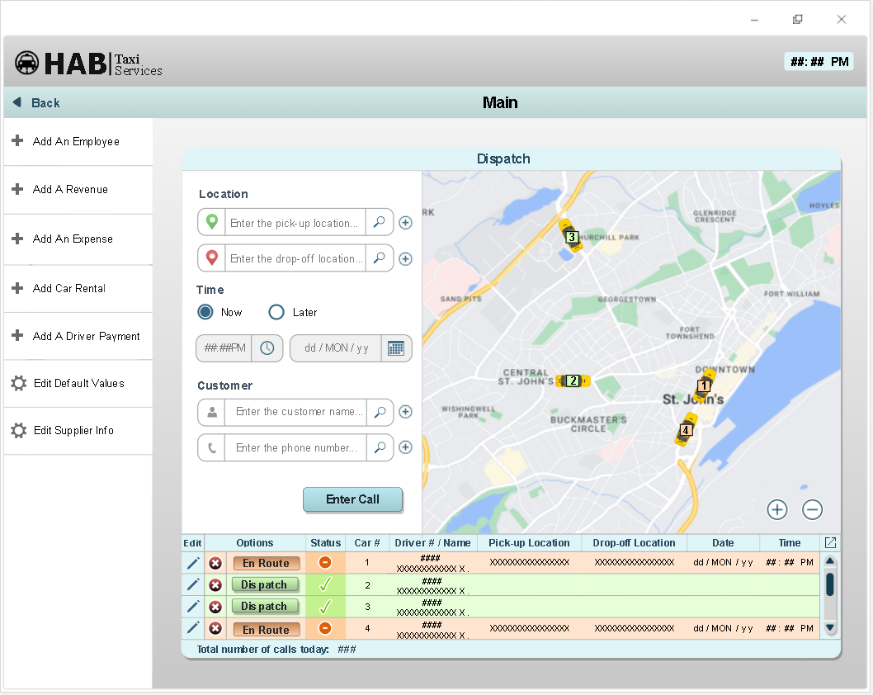

* Not required, I just made a minimized version and wanted to show it 😊

**User Interface Design**

**Edit Default Values Screen**

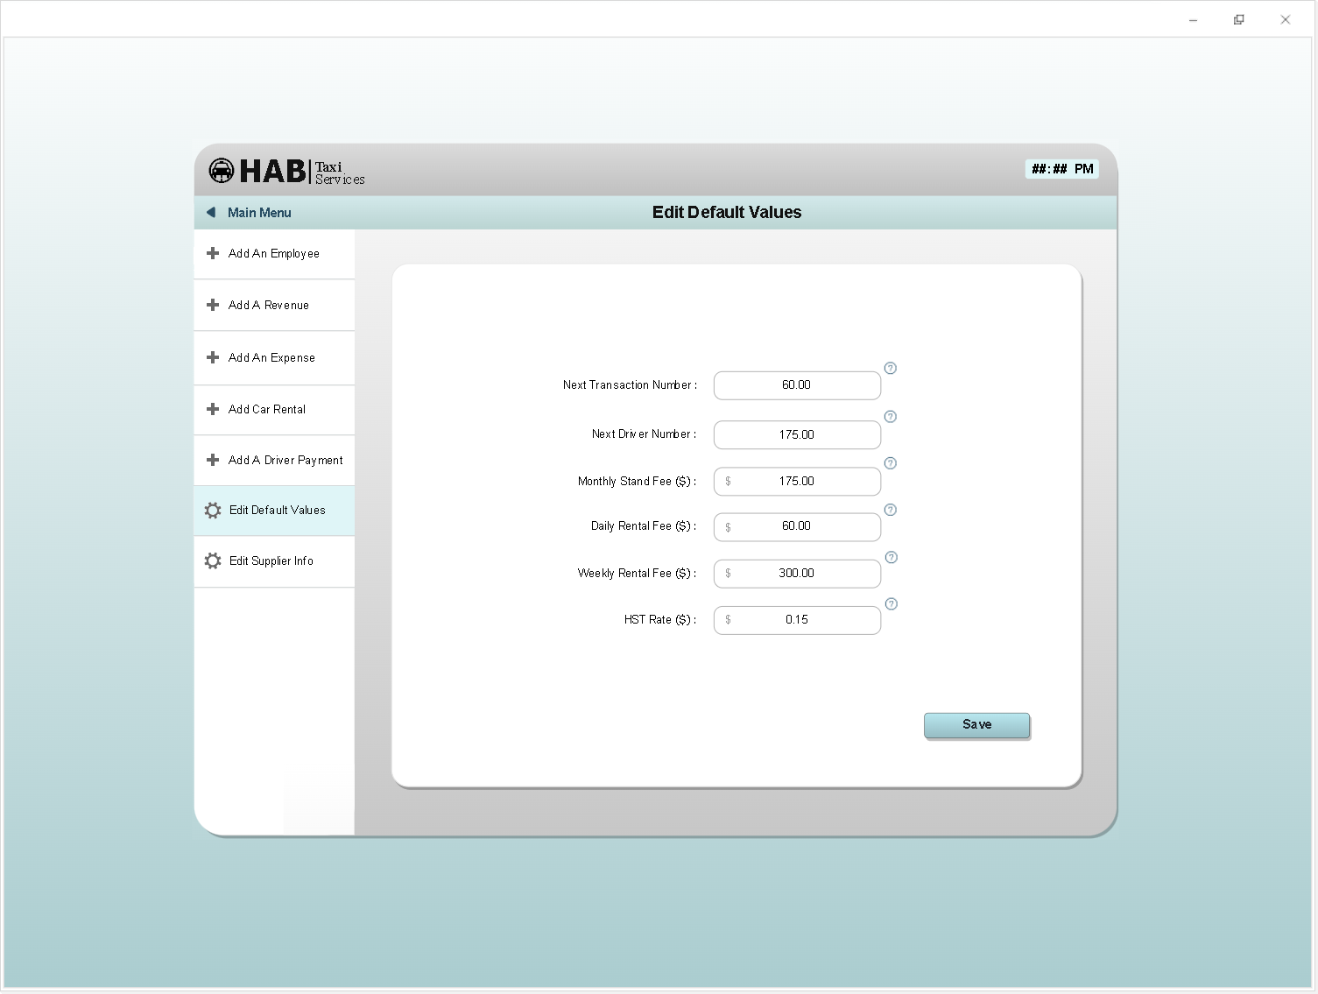

**User Interface Design**

**Enter New Employee Screen**

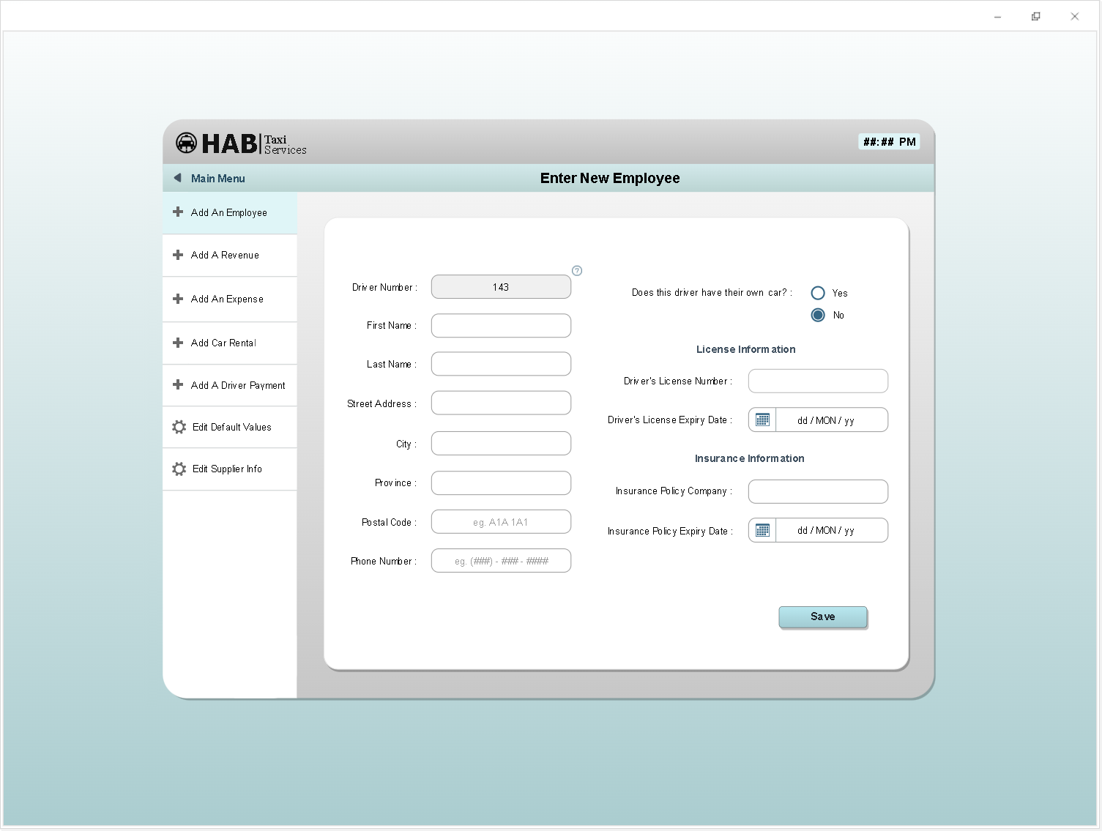

**Reports**

**Profit Listing**

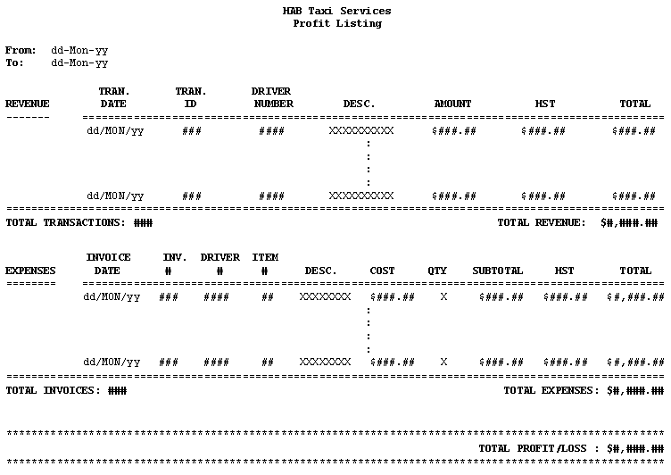

**Reports**

**Driver Financial Listing**

